**Conestoga College**

**Cloud Development and Operations**

**Sem - 2**

**PROG8870**

**Cloud Architectures and Infrastructure as Code**

**Final Project**

**Name:- Durlabh Tilavat(8938972)**

**Professor:- Vikas Vattikonda**

This is my GitHub repository link: <https://github.com/Durlabh8972/PROG8870-Final-Project-Durlabh-8938972>

AWS Credential set:

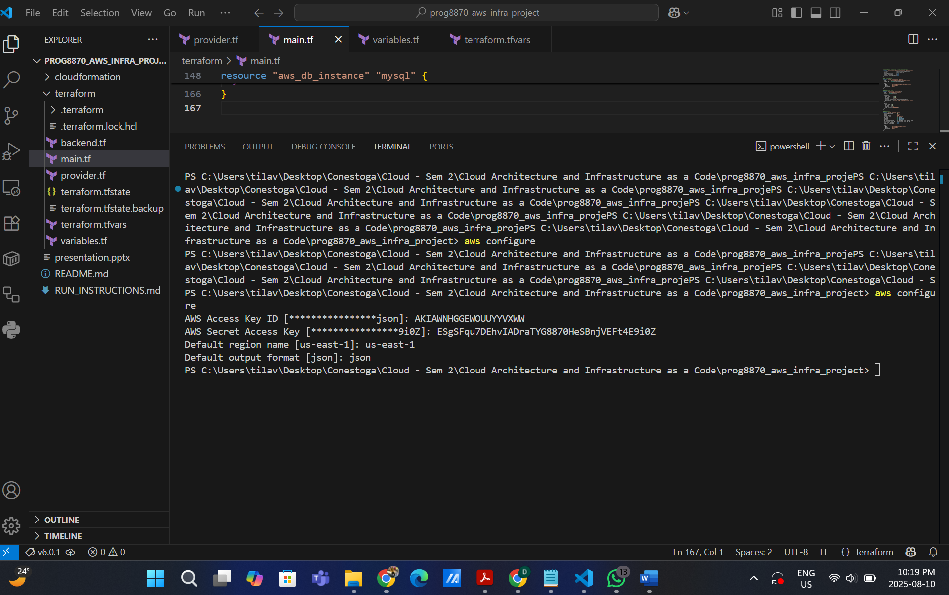

Terraform init: 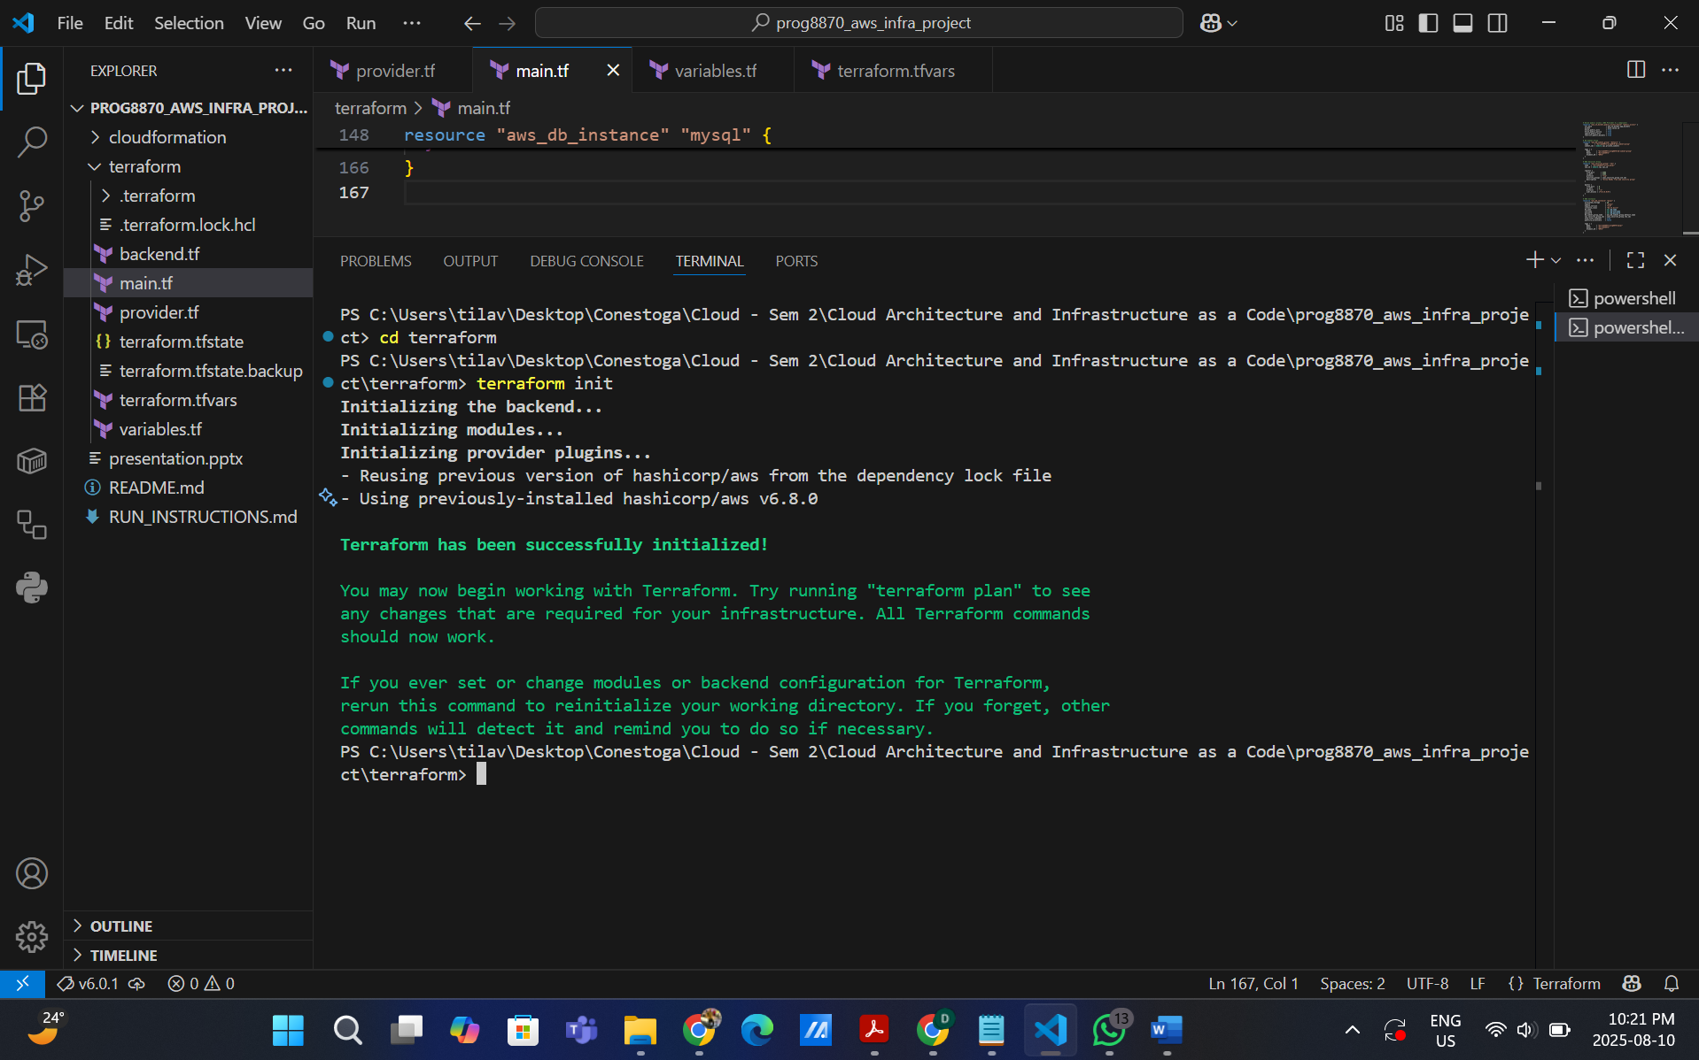

Terraform plan:

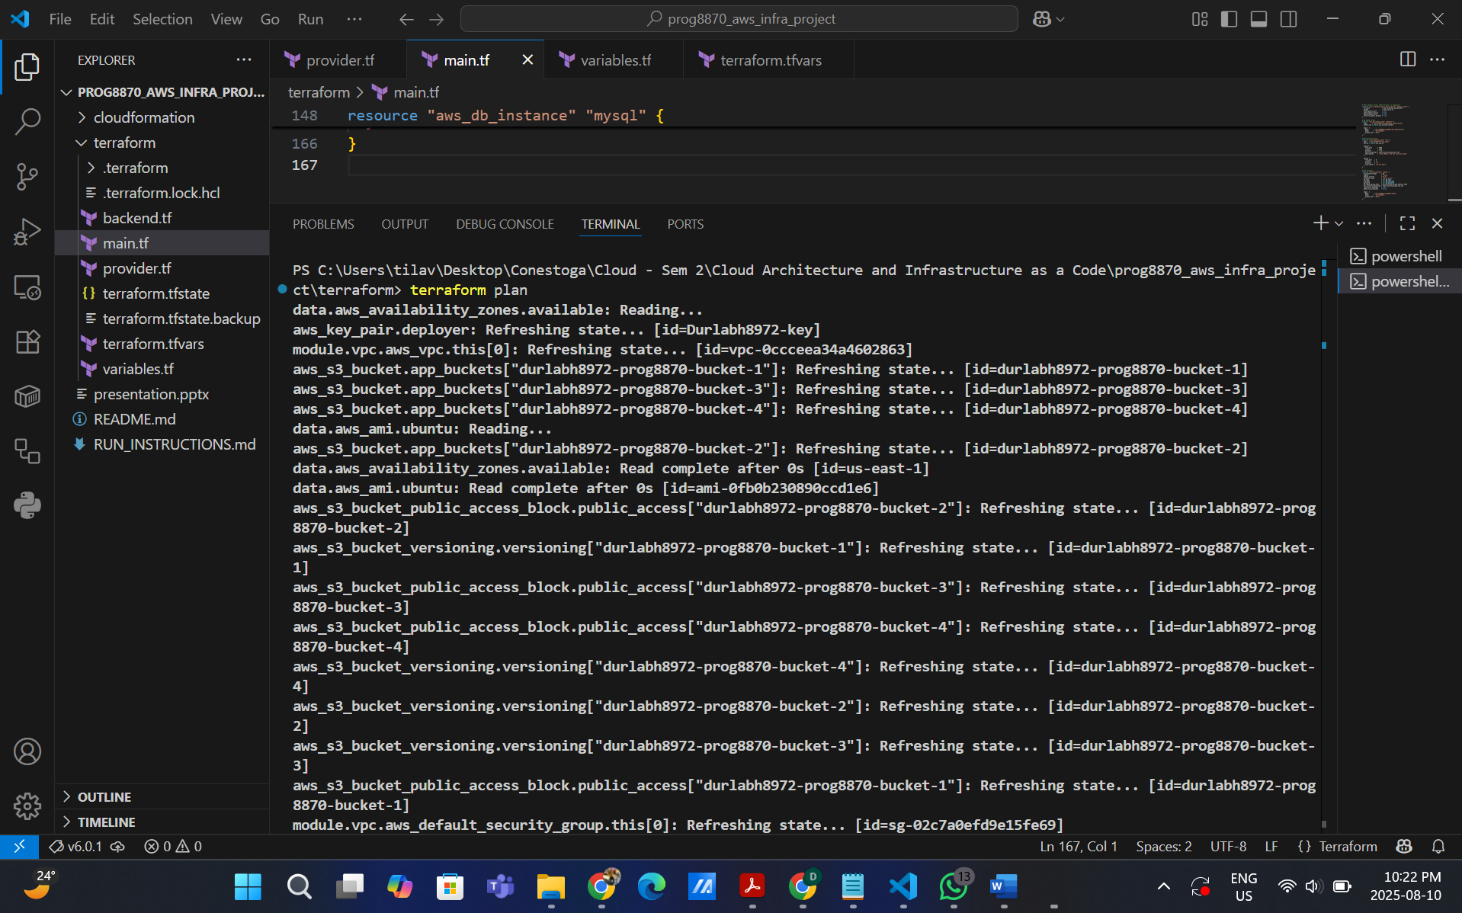

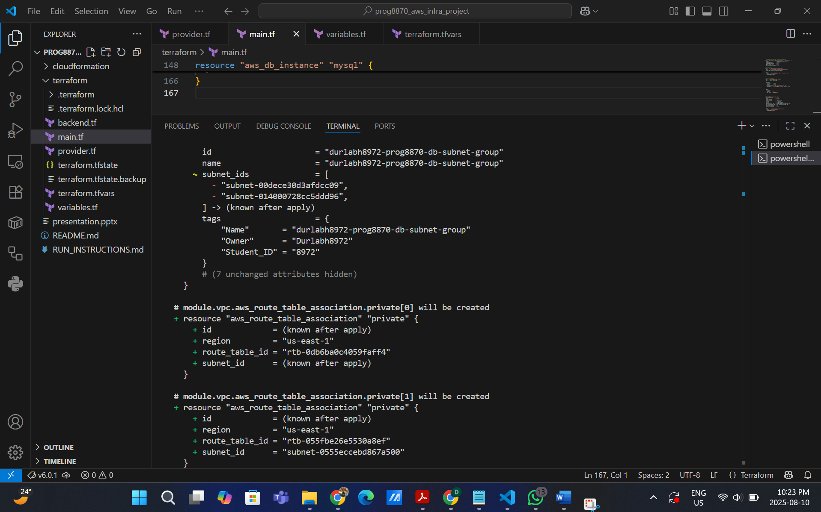

Terraform apply:

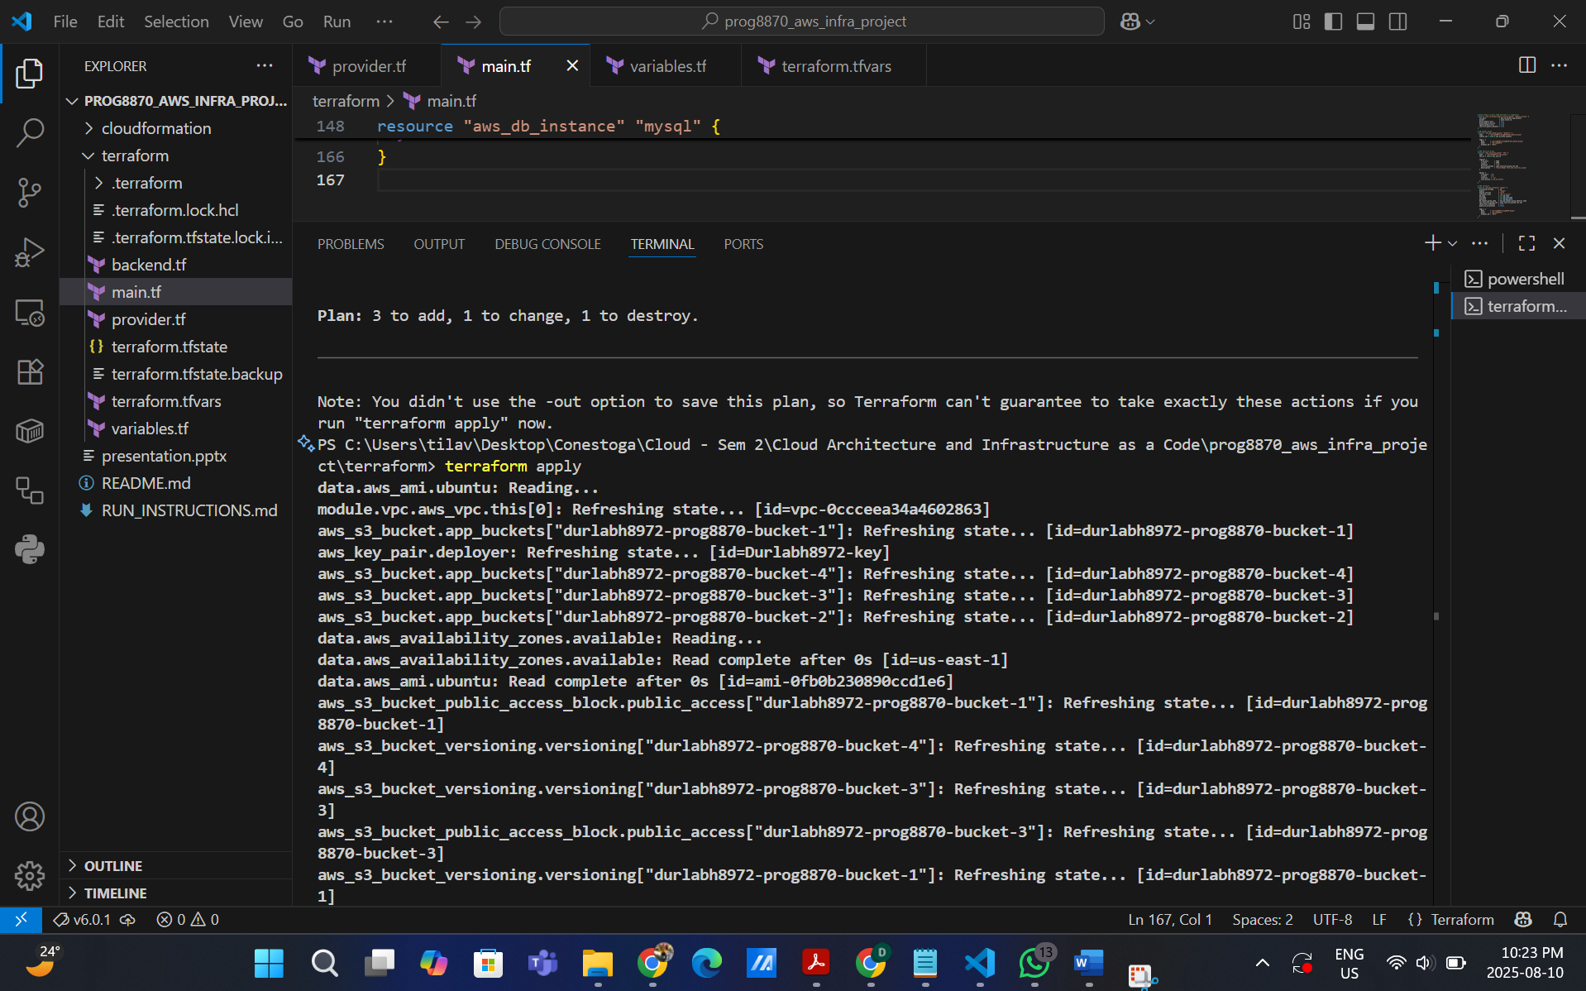

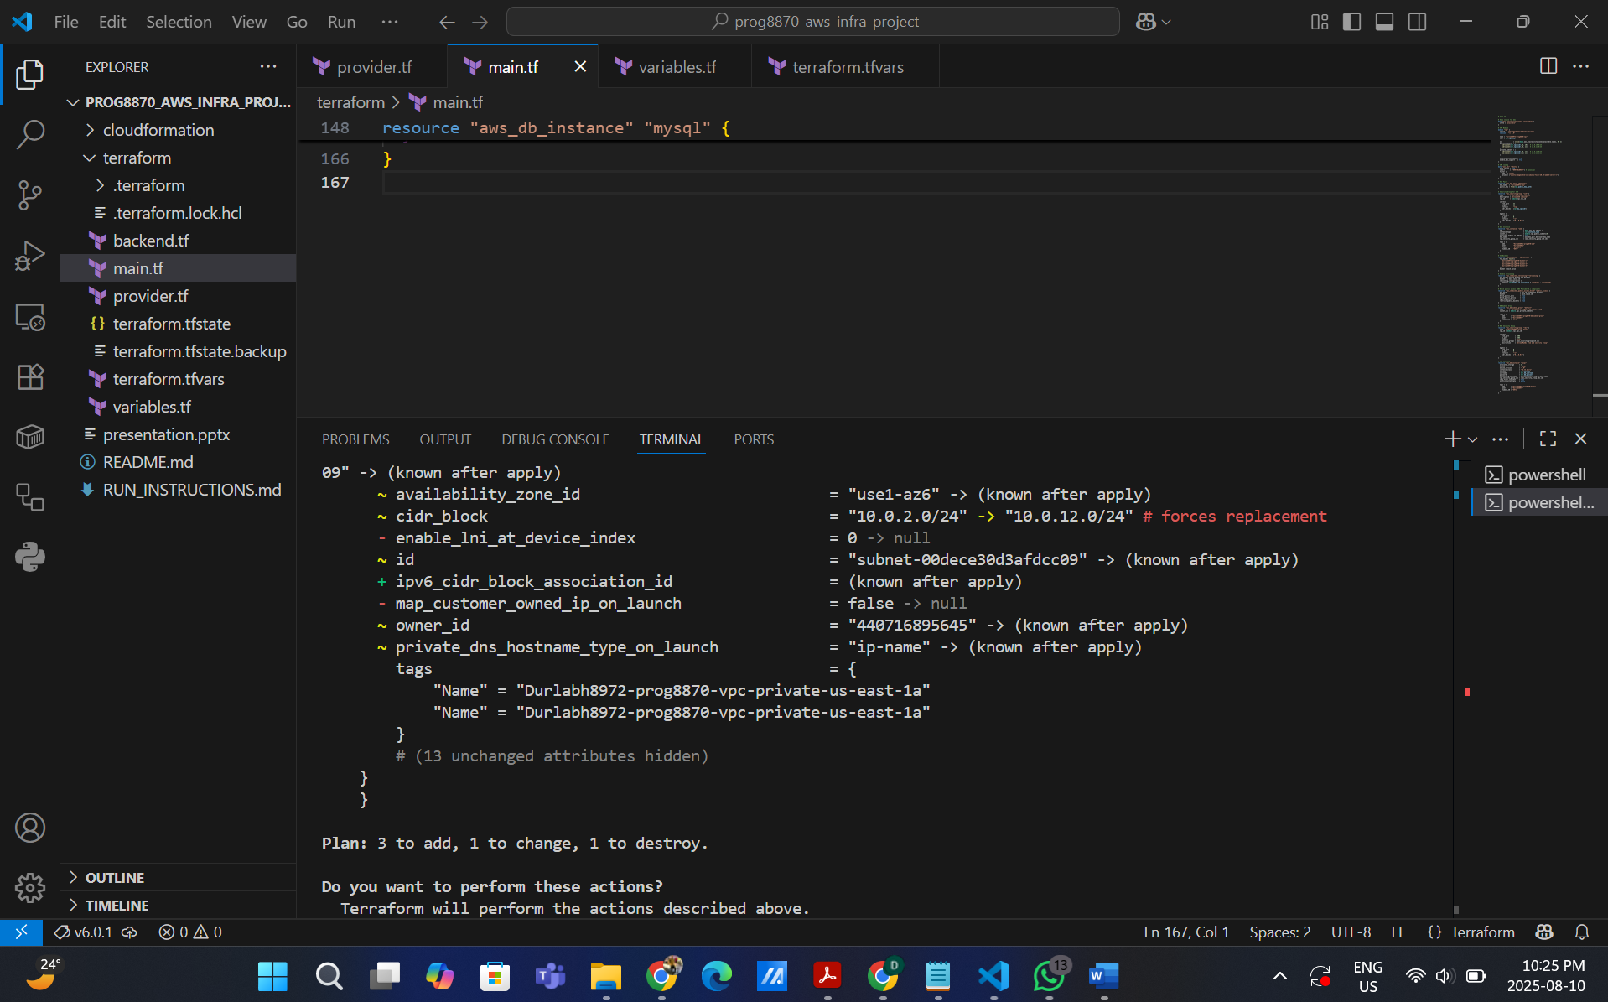

**S3 Bucket + Versioning Enable**

1. durlabh8972-prog8870-bucket-1

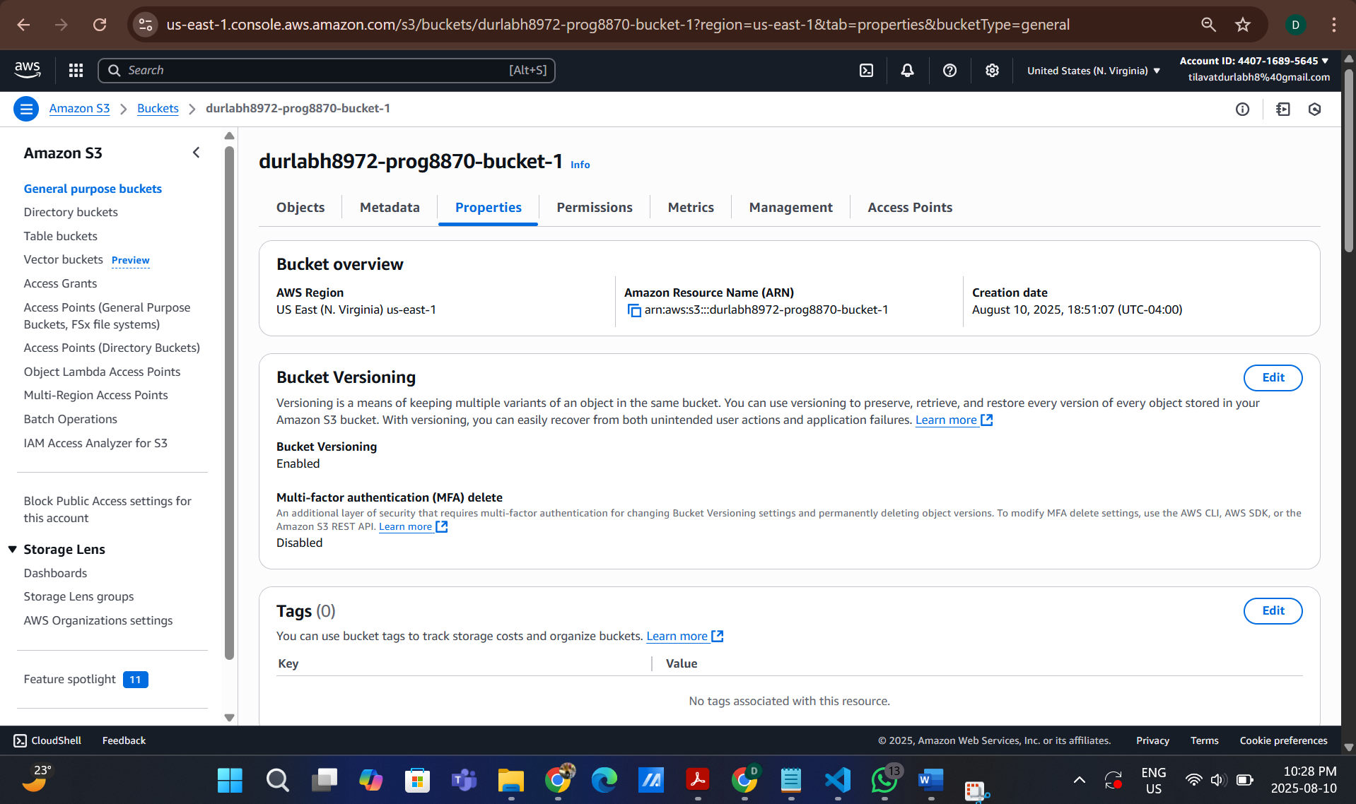

2. durlabh8972-prog8870-bucket-2

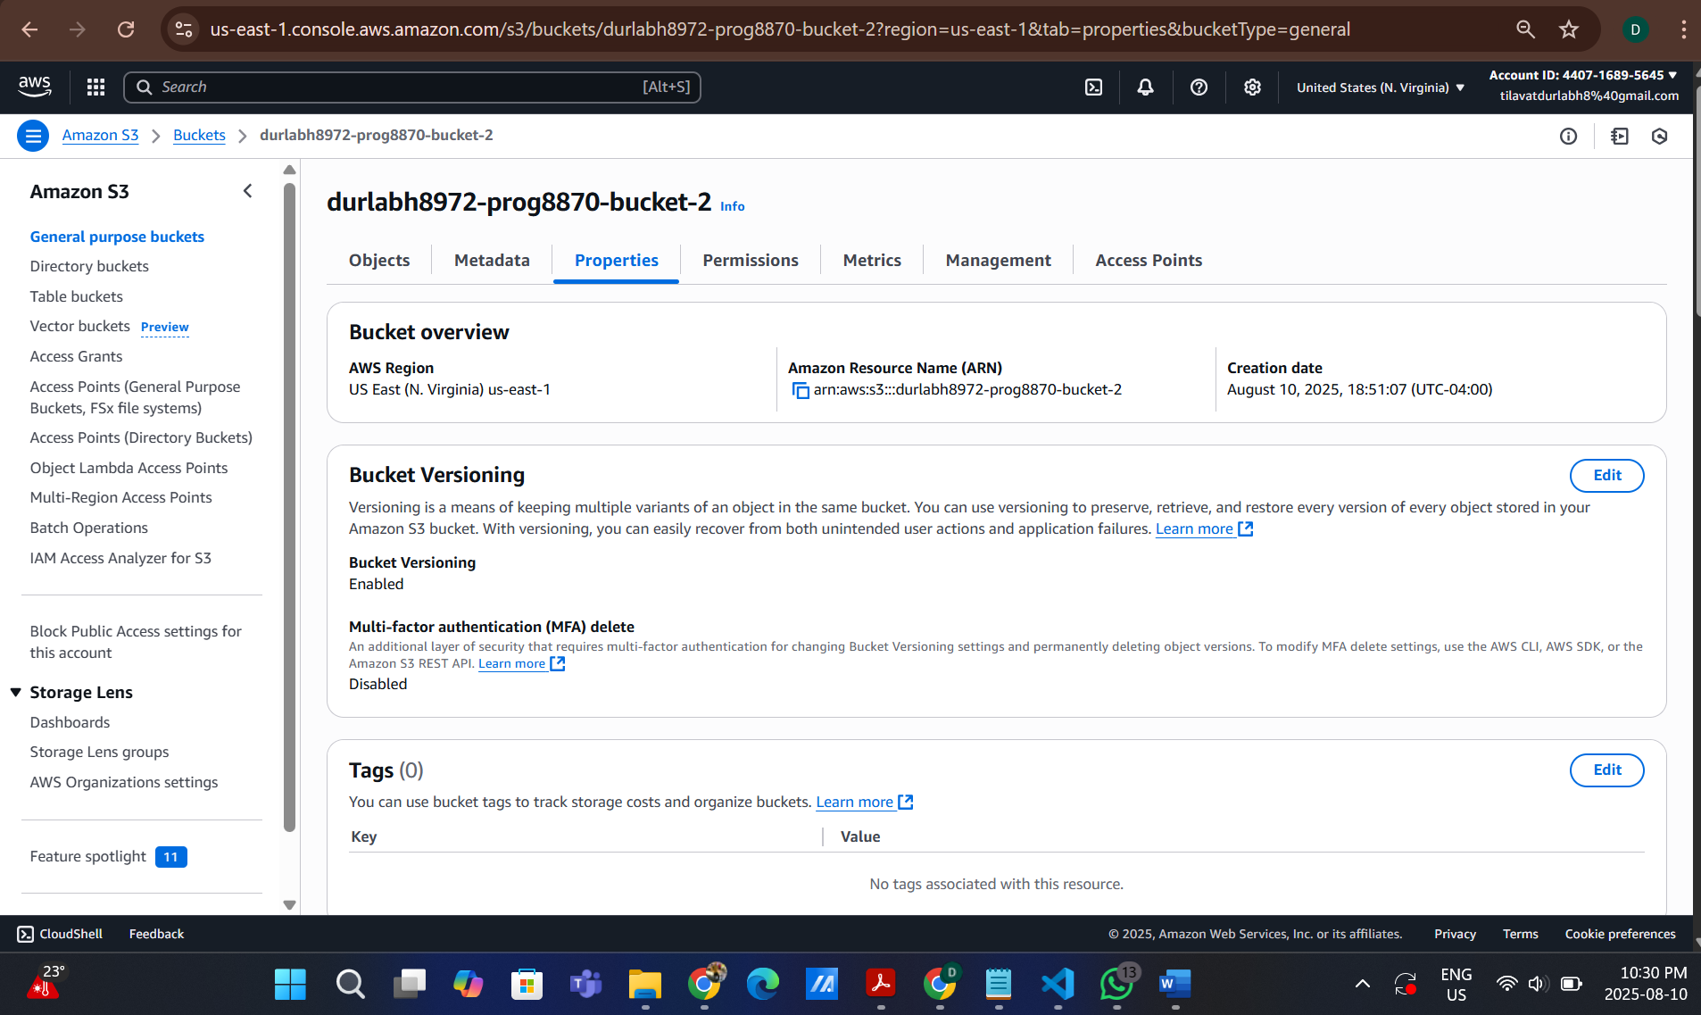

3. durlabh8972-prog8870-bucket-3

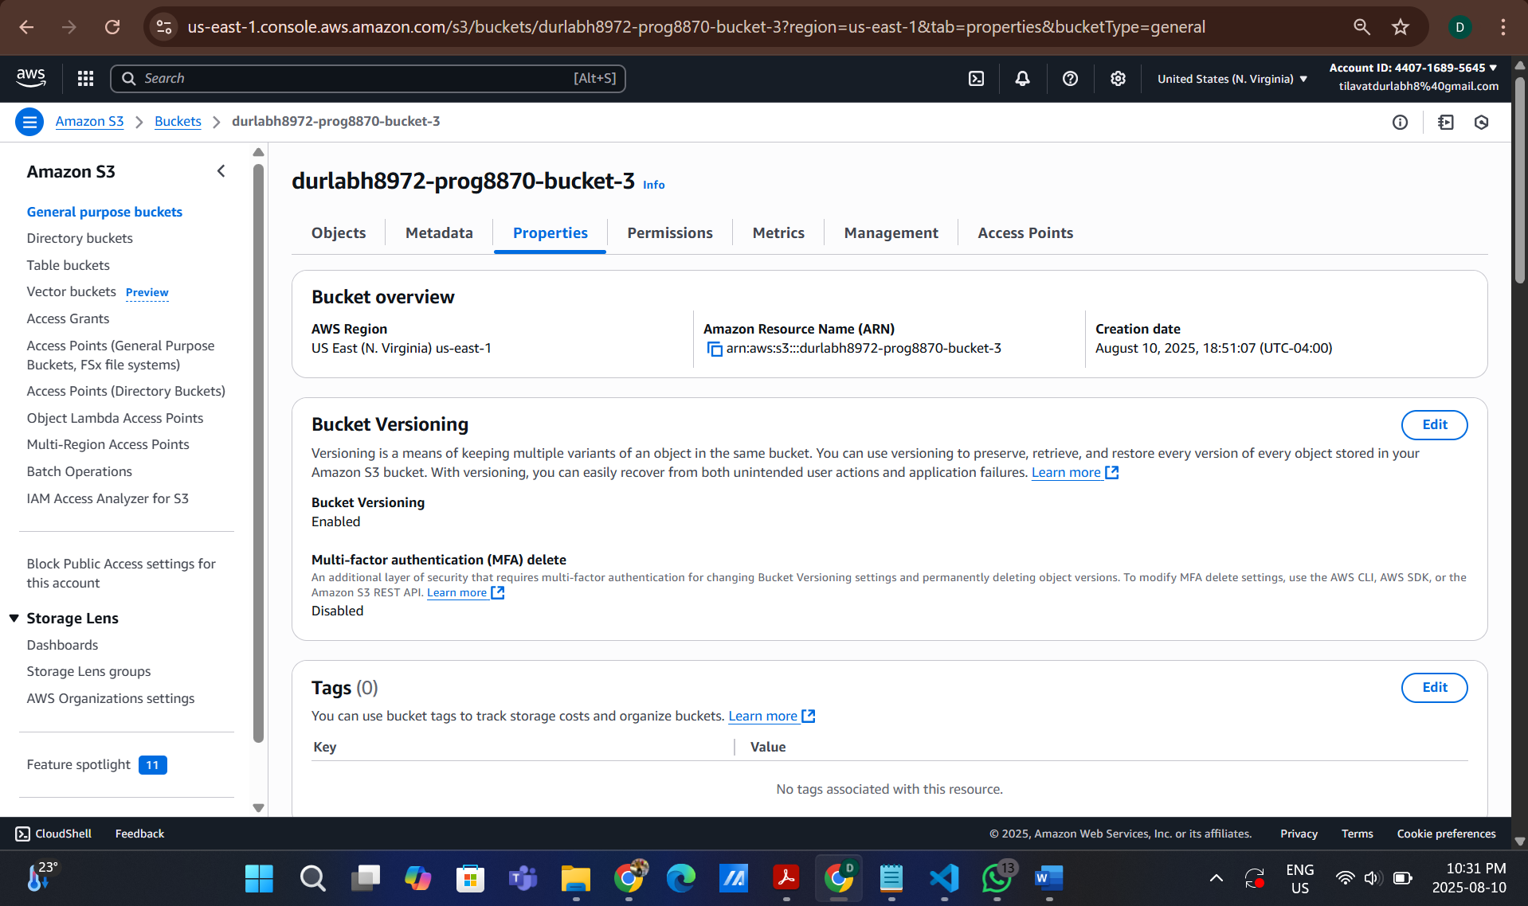

4. durlabh8972-prog8870-bucket-4

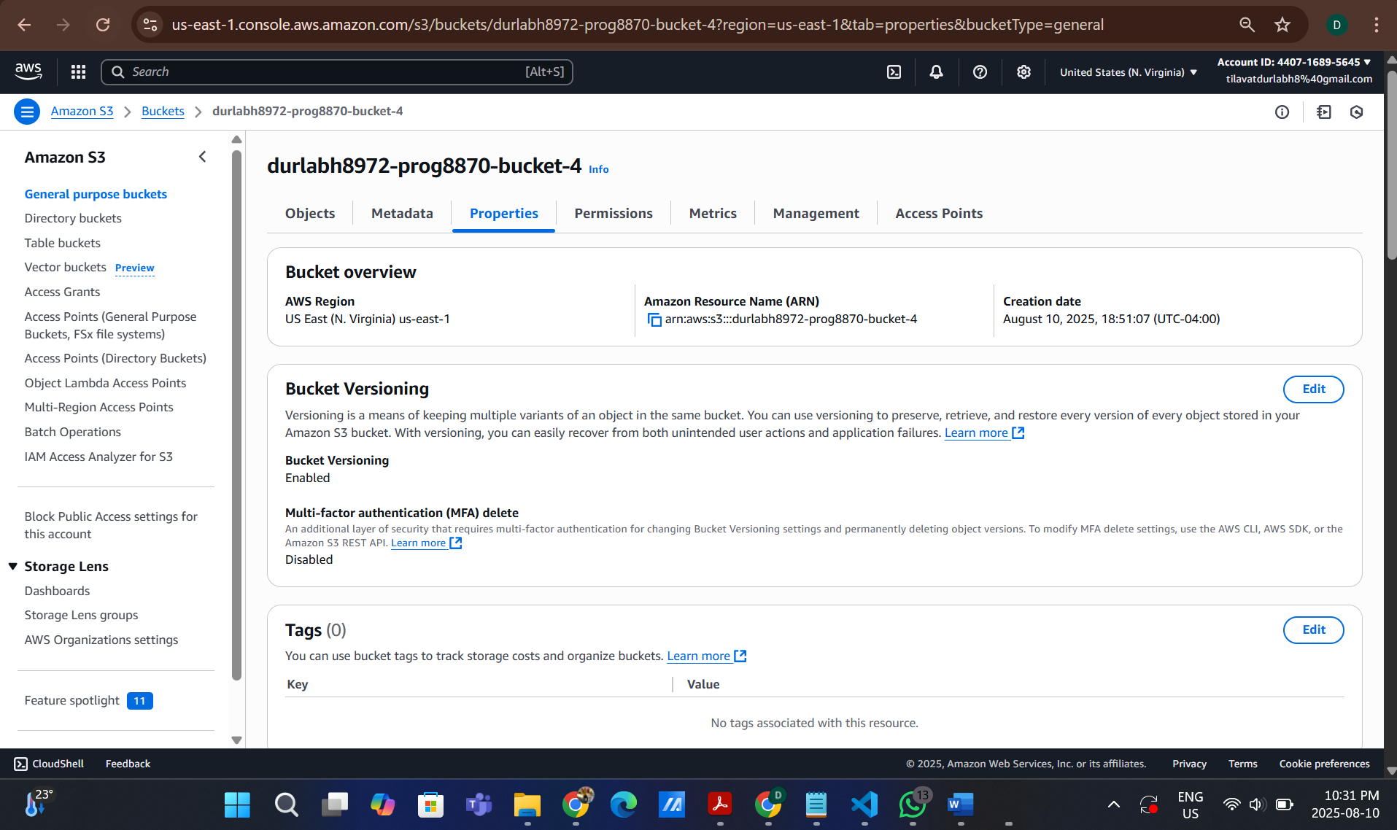

EC2 Instance:

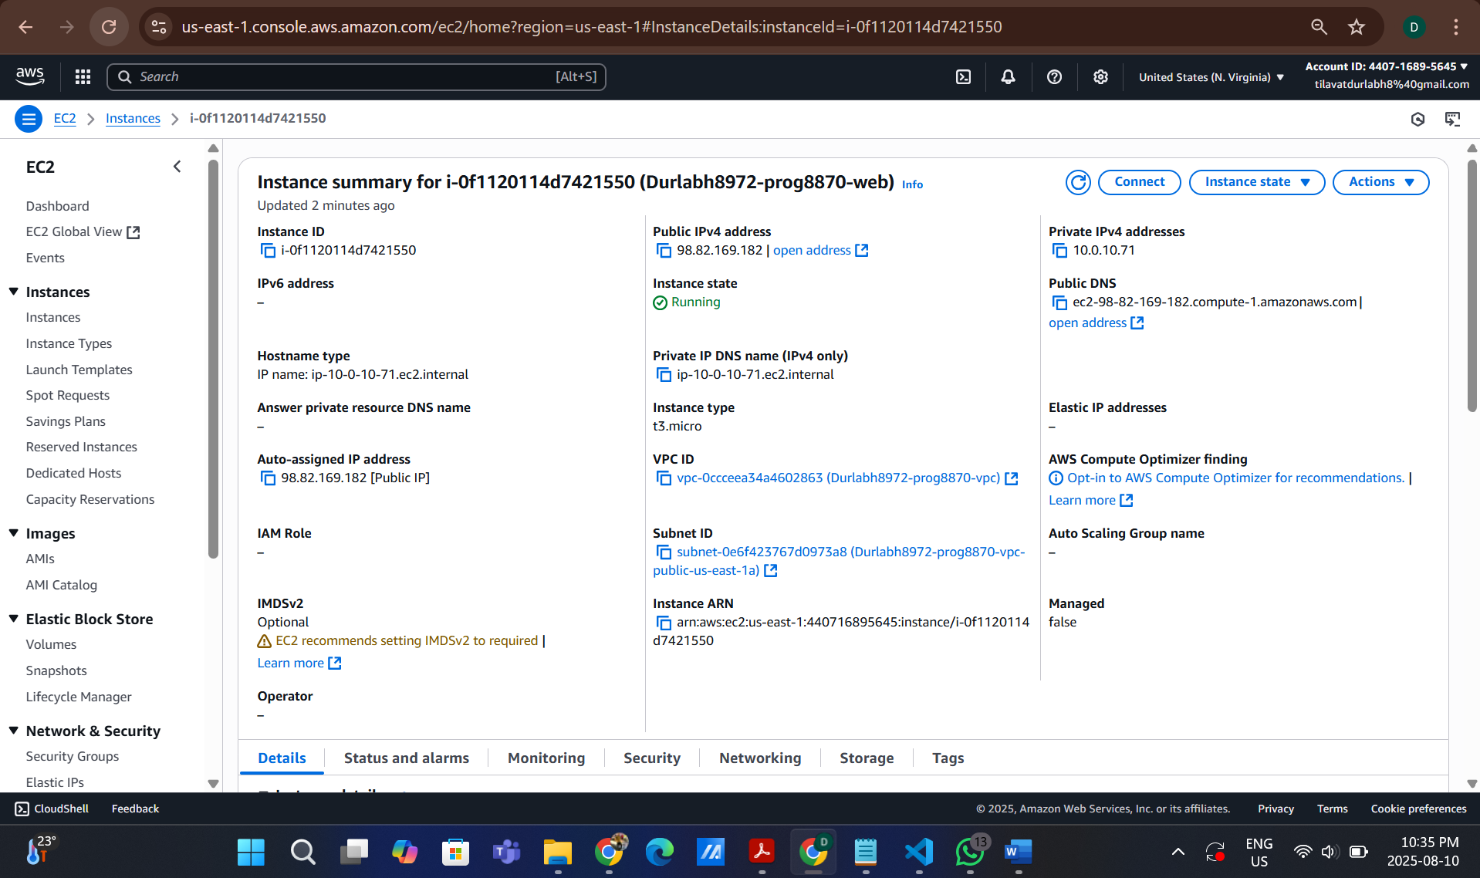

RDS Database:

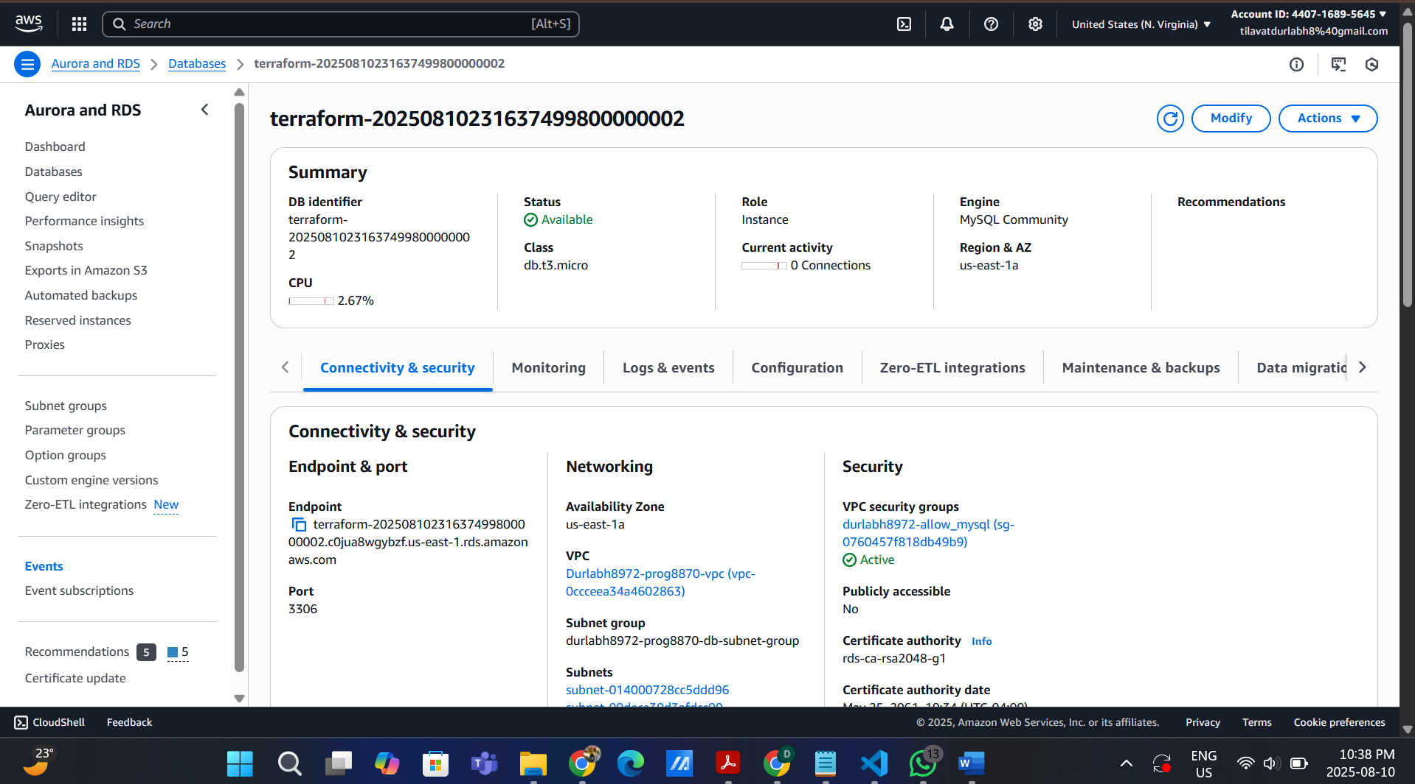

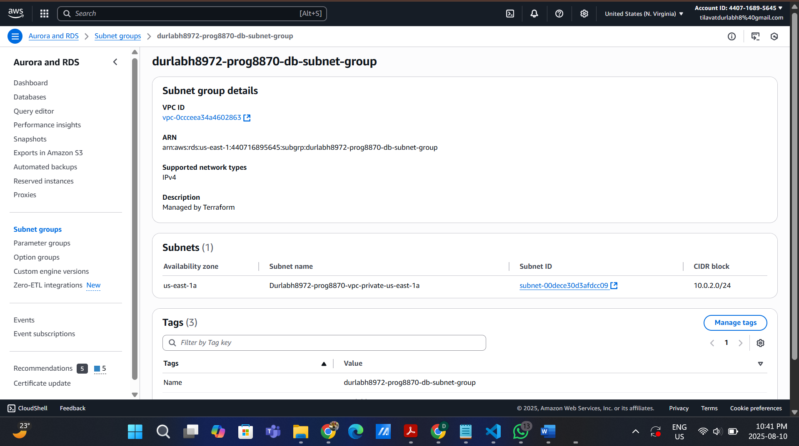

VPC:

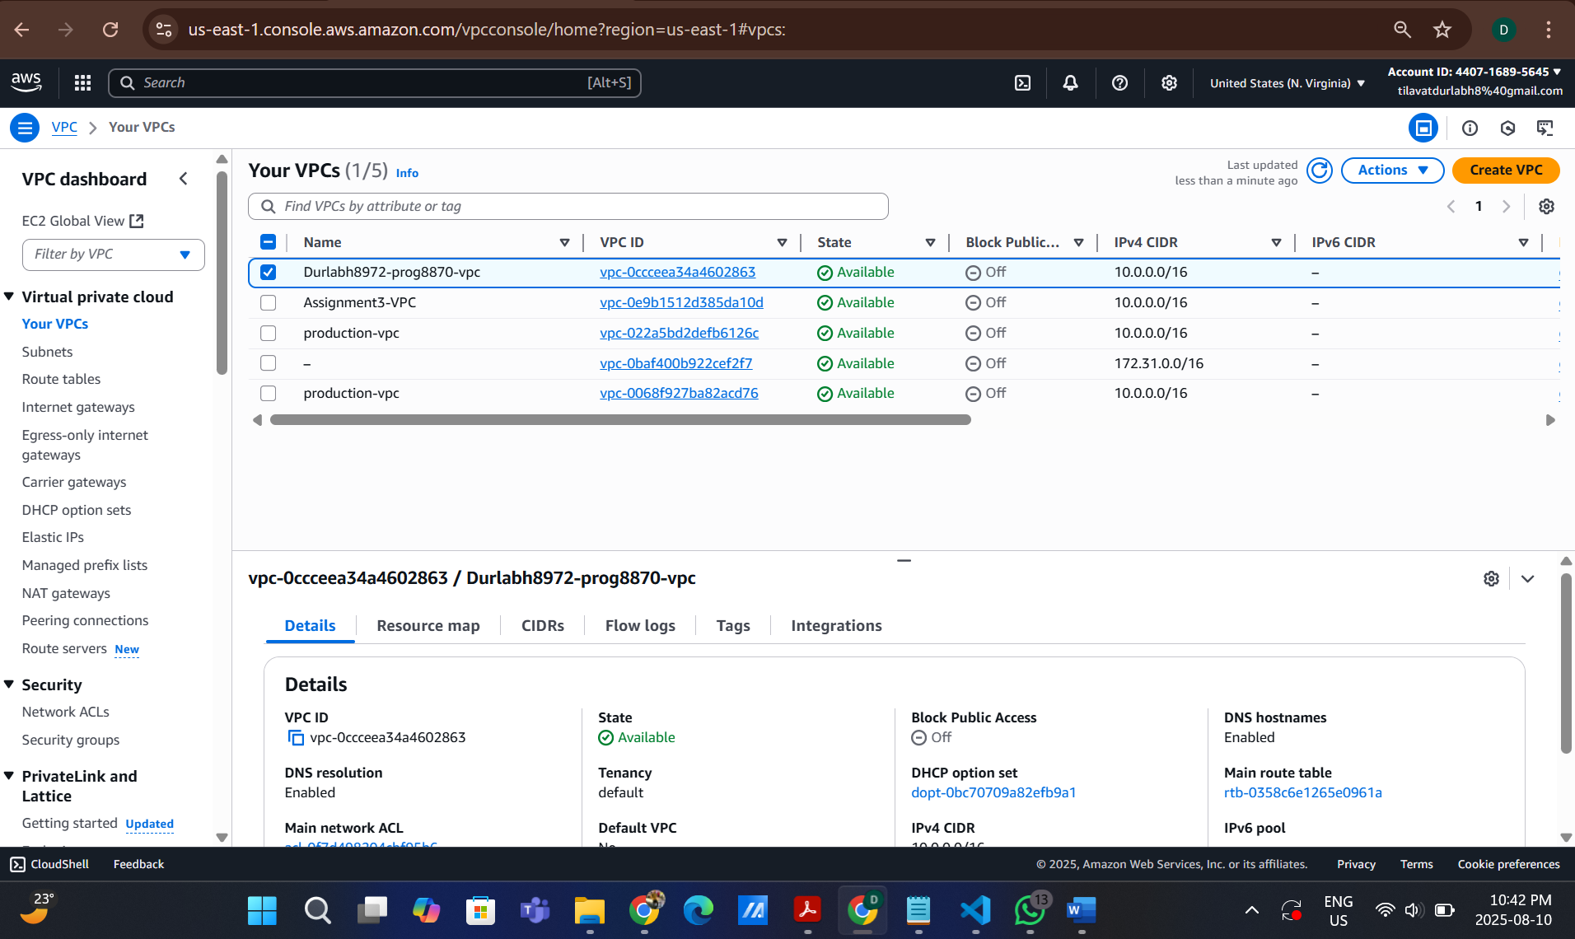

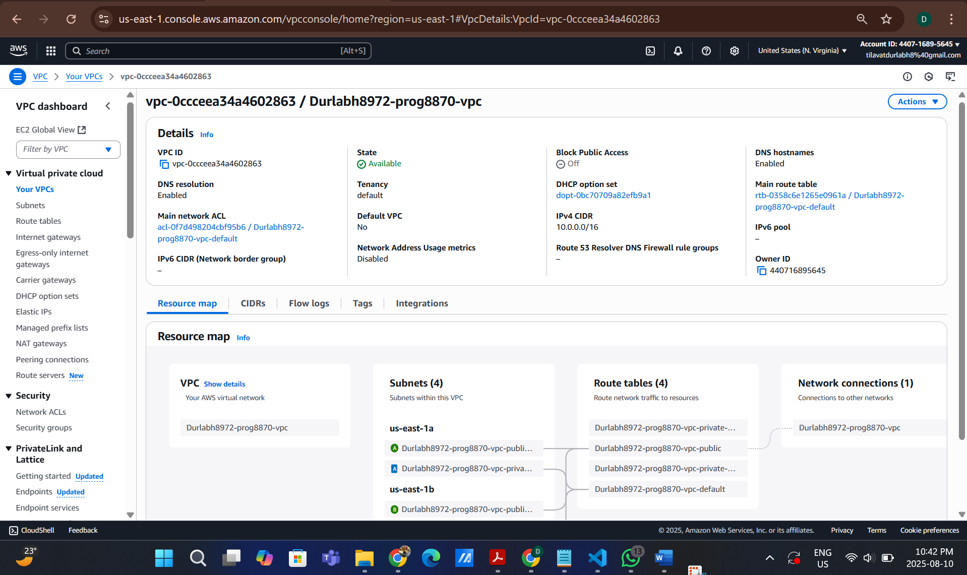

**Subnets:**

1. Durlabh8972-prog8870-vpc-public-us-east-1b

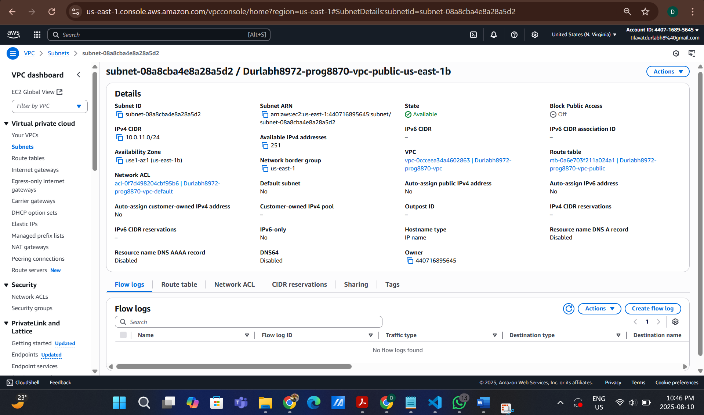

2. Durlabh8972-prog8870-vpc-private-us-east-1b

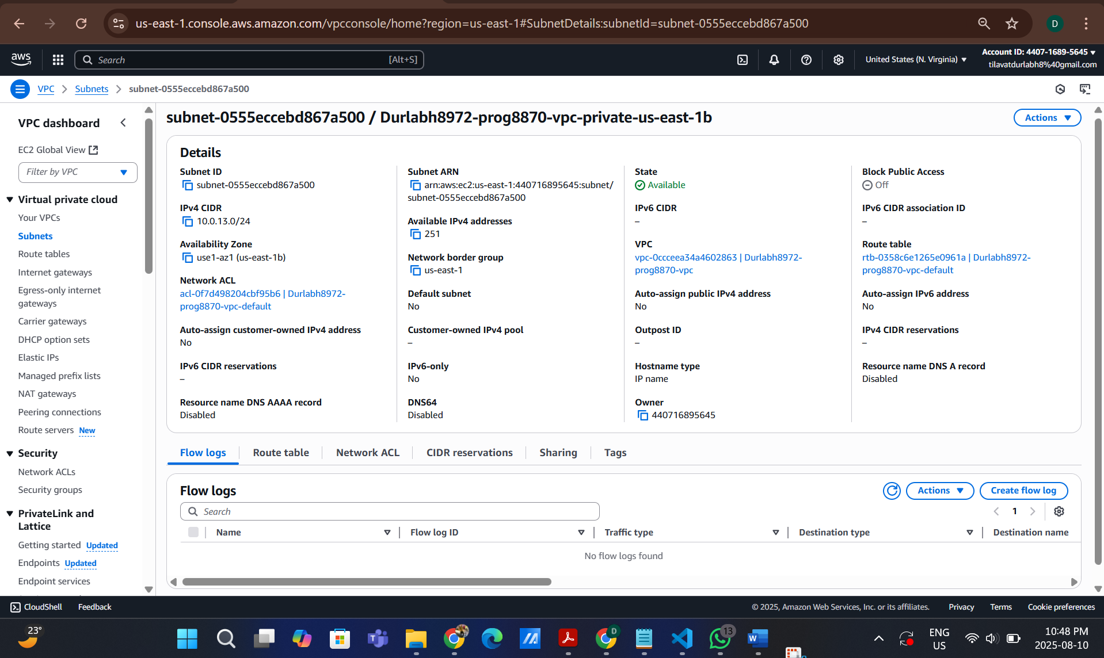

3. Durlabh8972-prog8870-vpc-private-us-east-1a

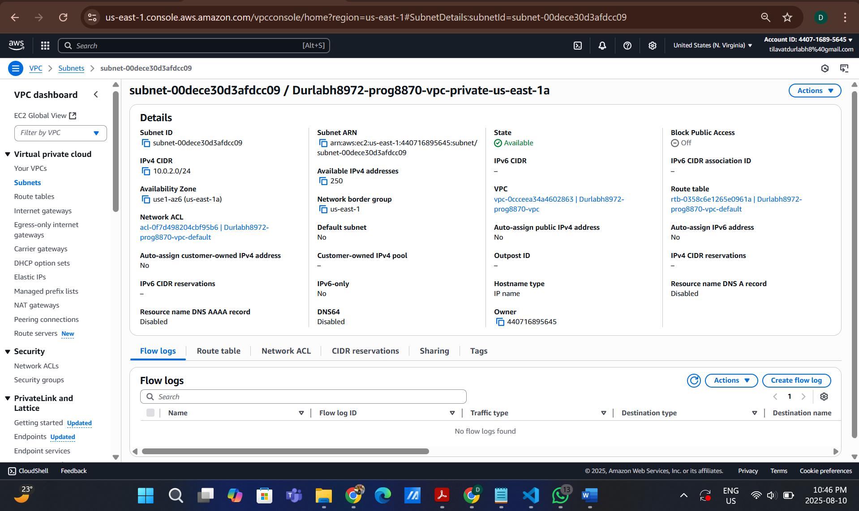

4. Durlabh8972-prog8870-vpc-public -us-east-1a

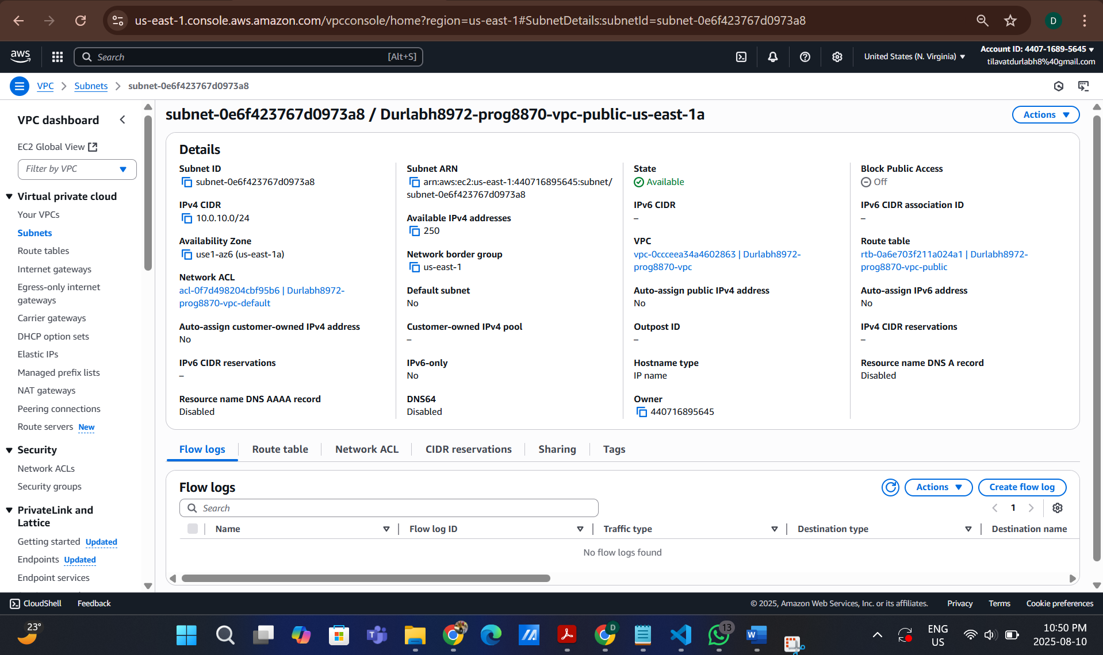

**Route Tables:**

1.Durlabh8972-prog8870-vpc-public

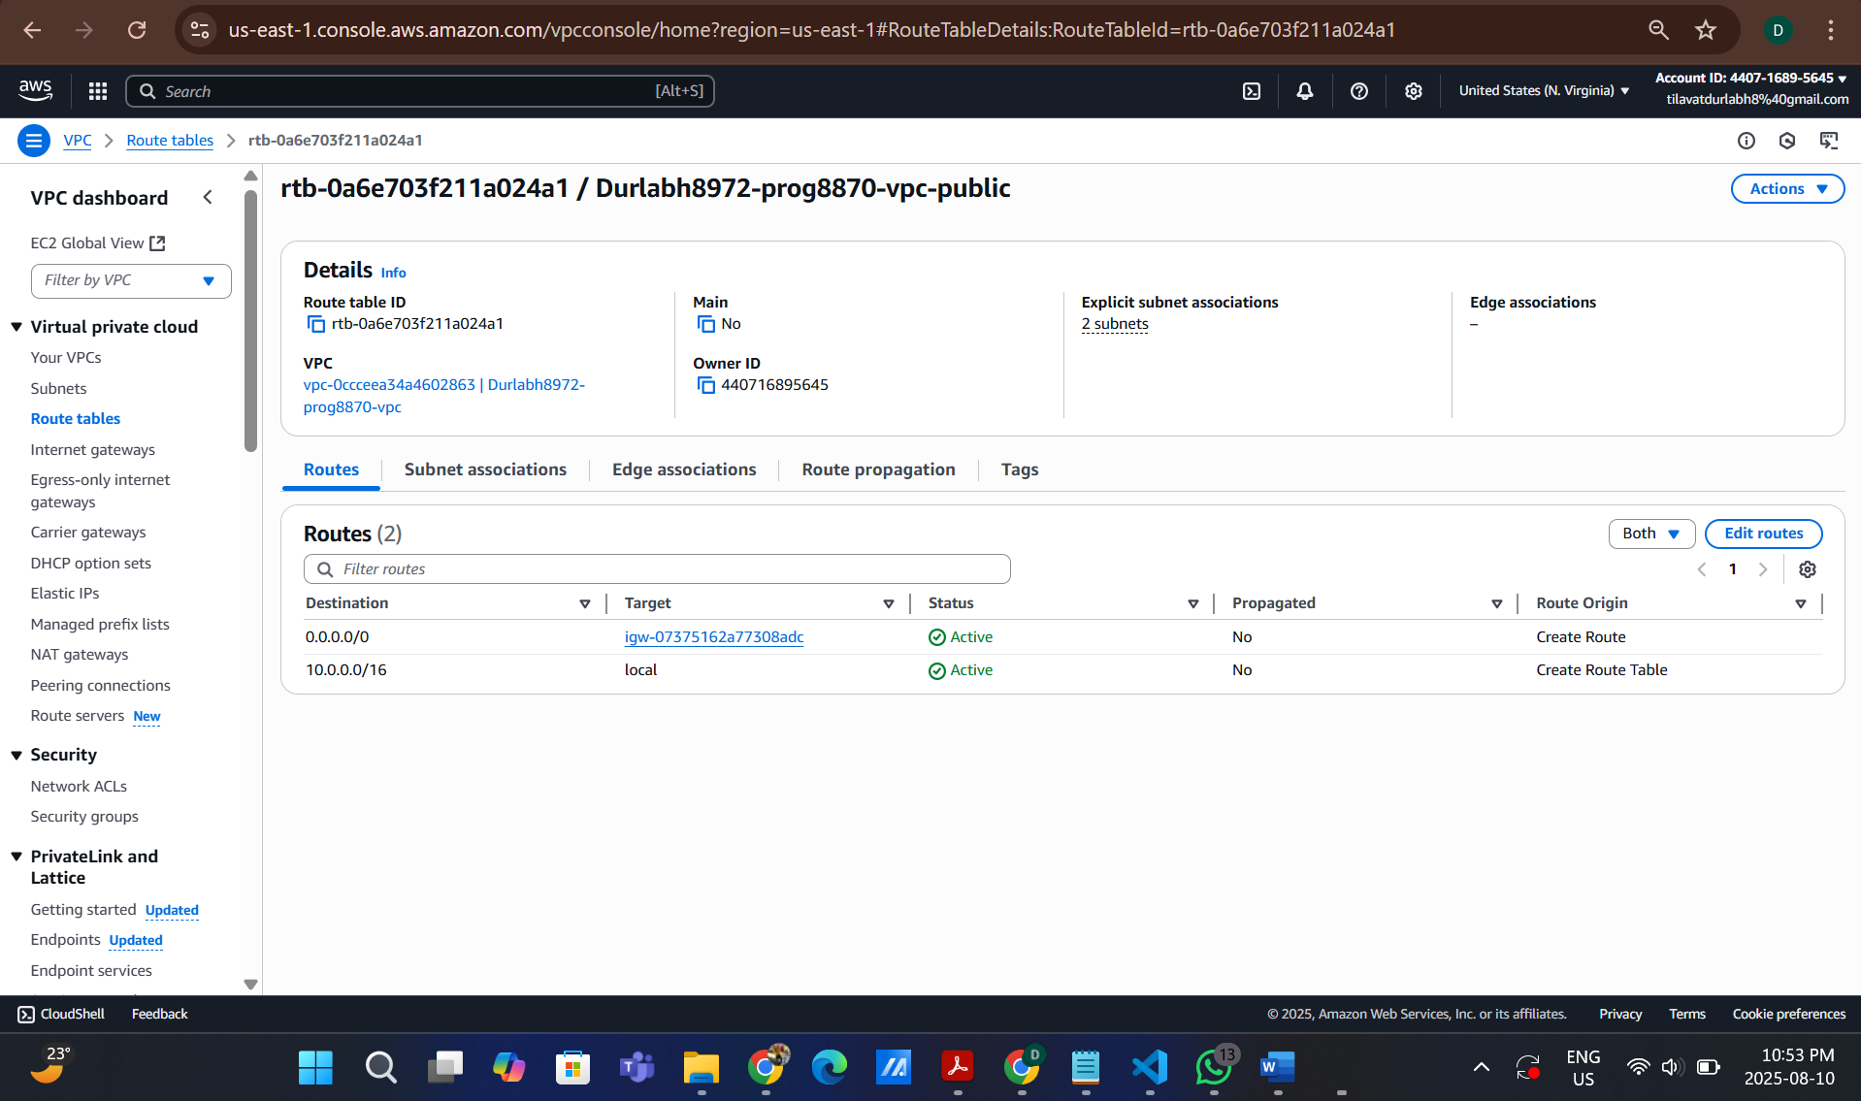

2. Durlabh8972-prog8870-vpc-private-us-east-1b

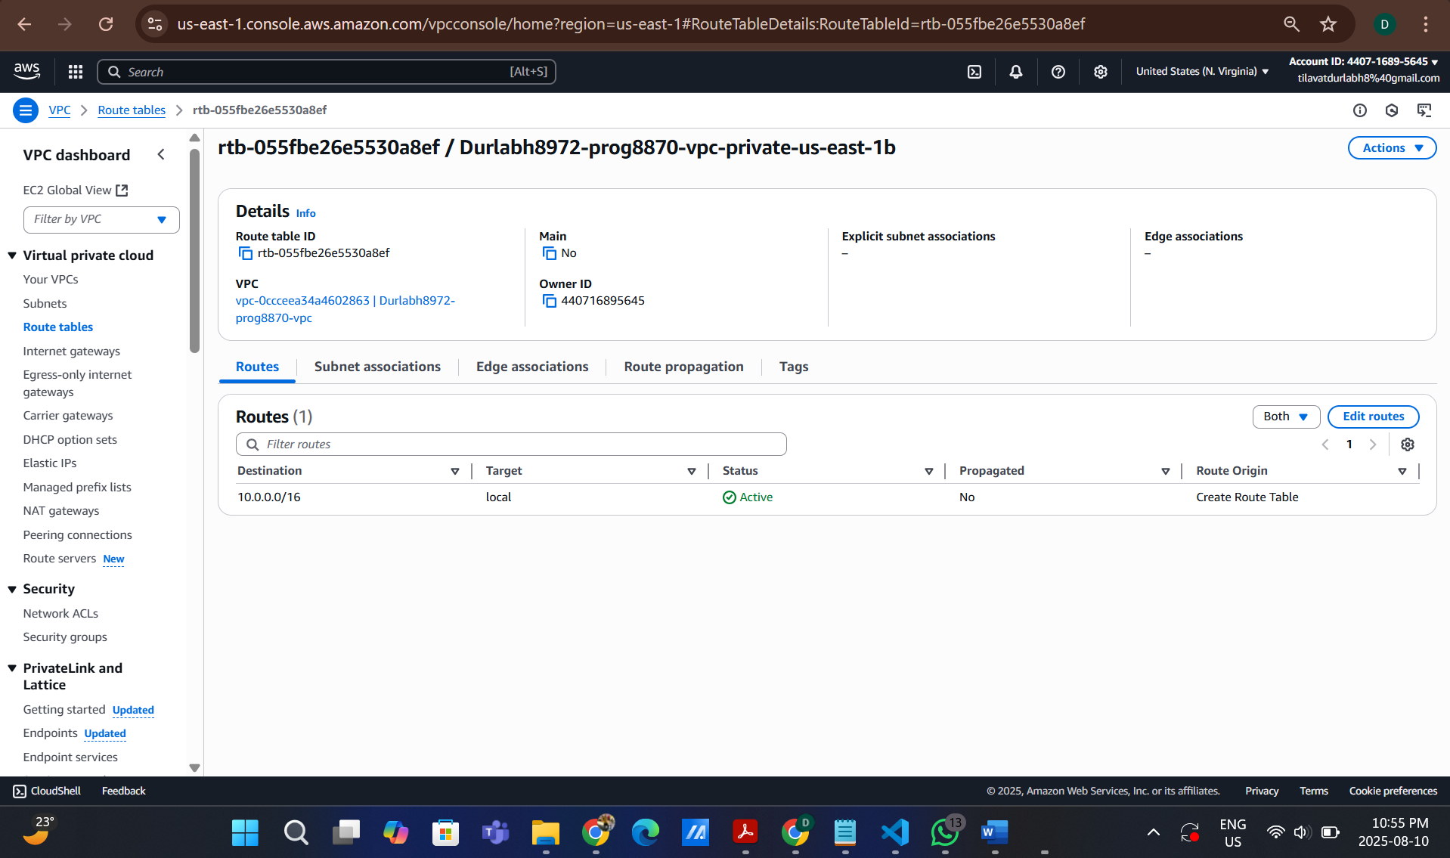

3. Durlabh8972-prog8870-vpc-private-us-east-1a

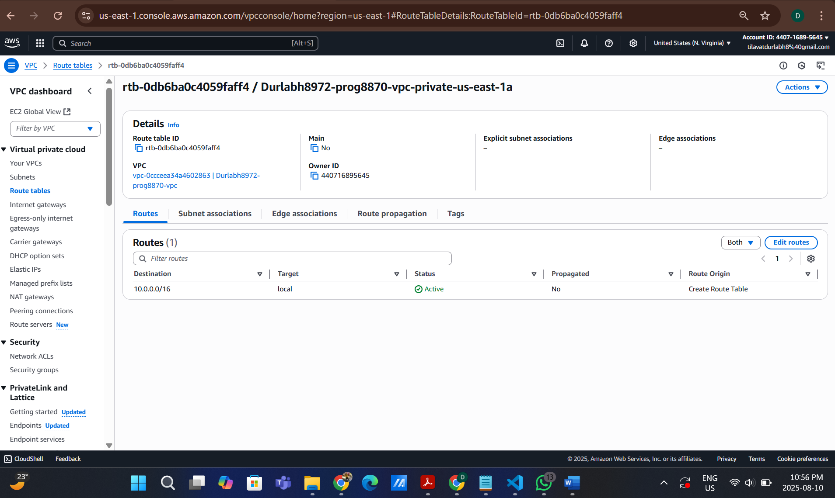

4. Durlabh8972-prog8870-vpc-default

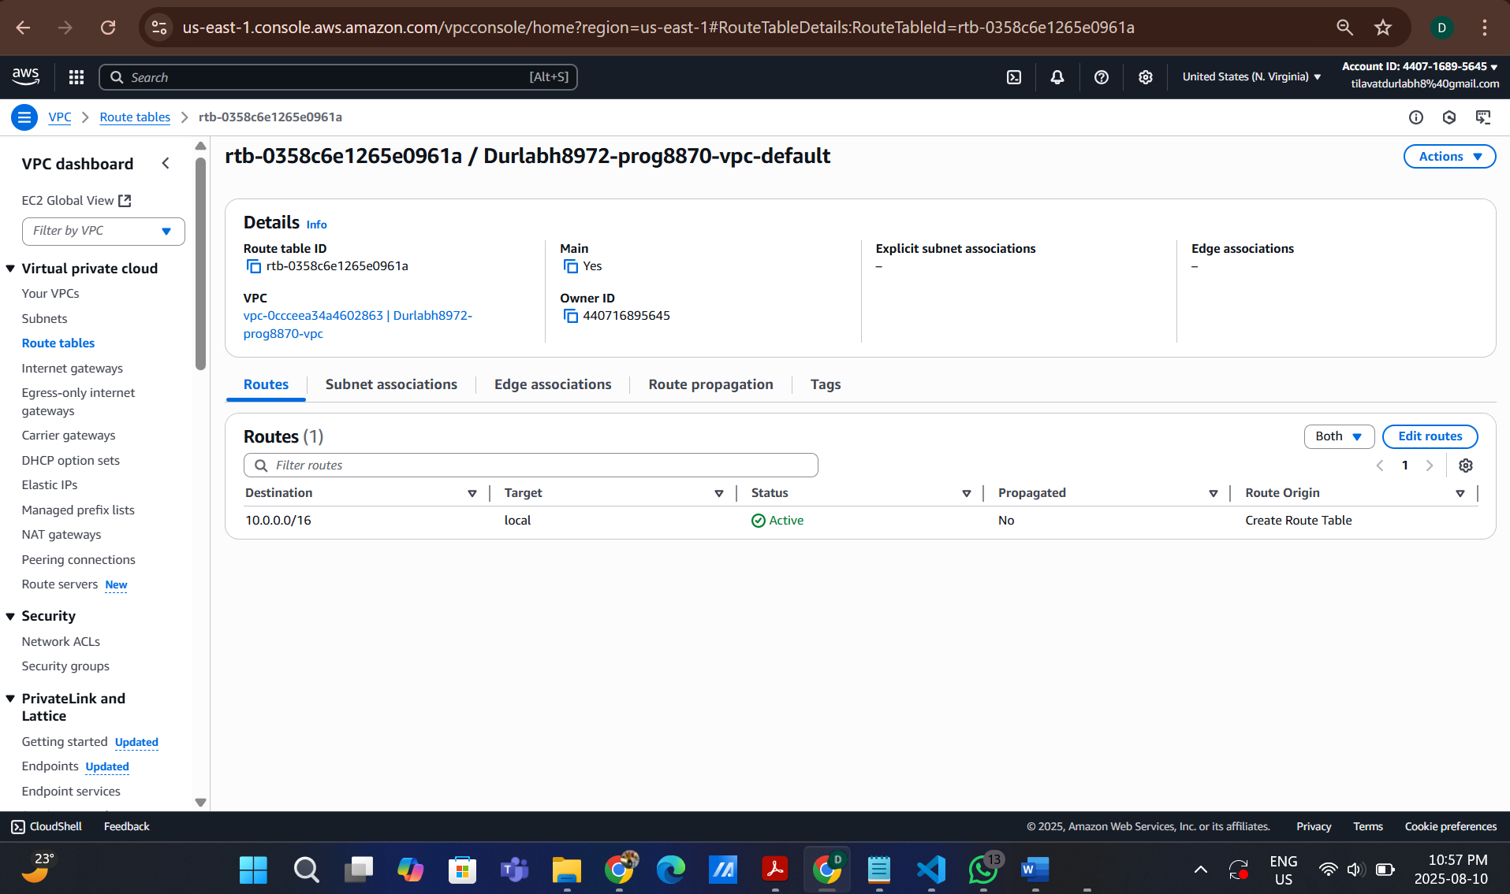

Security Groups

1. allow_ssh with port 22

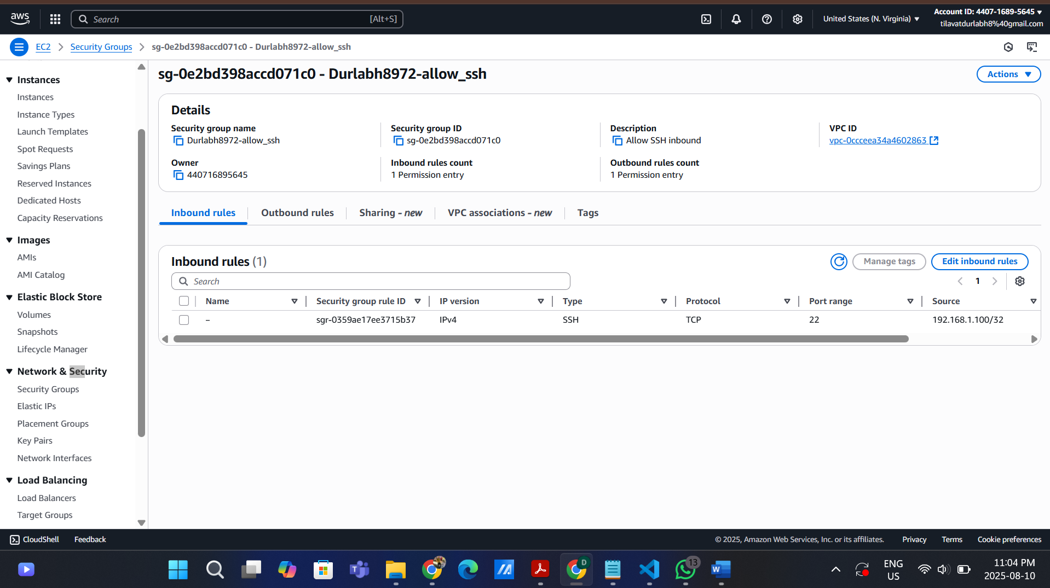

2. allow_mysql with port 3306

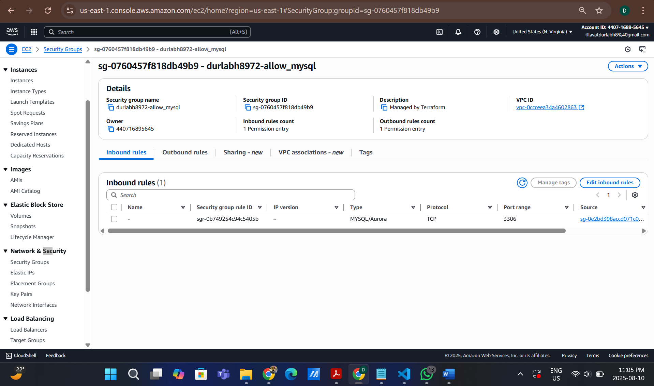

Internet Gateway:

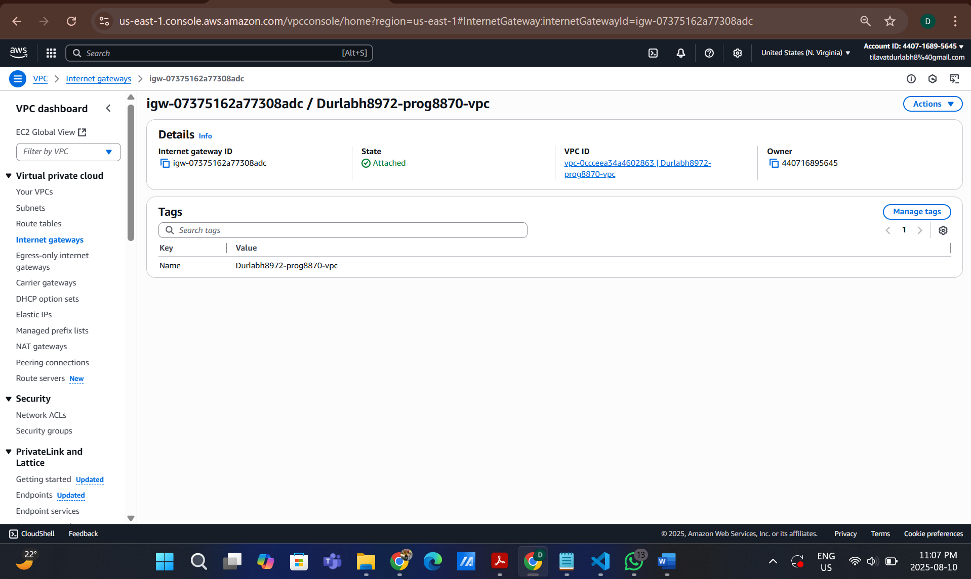

**CloudFormation:**

S3 Stack:

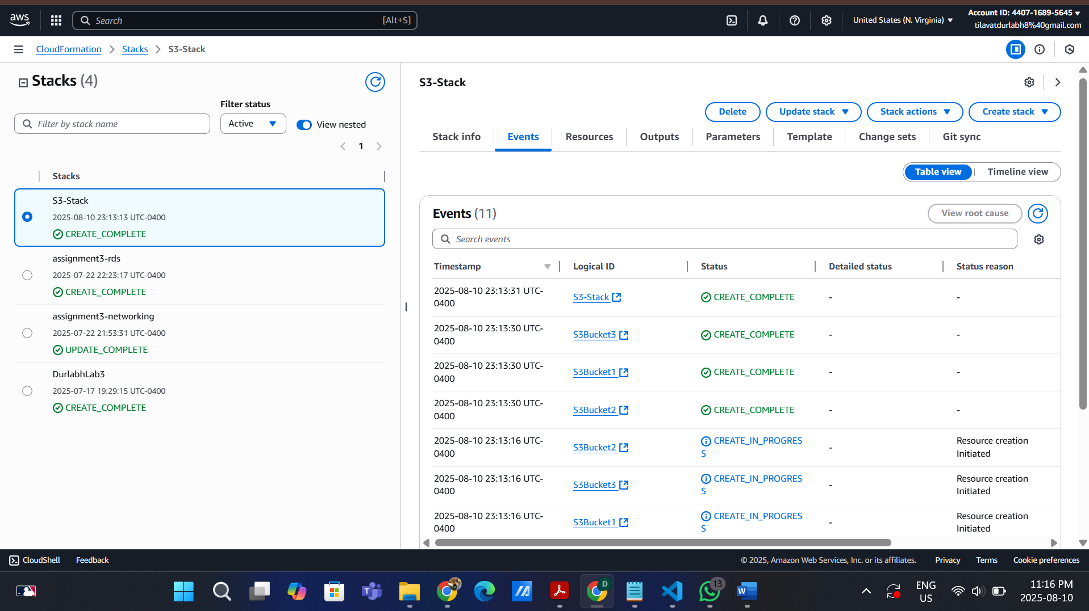

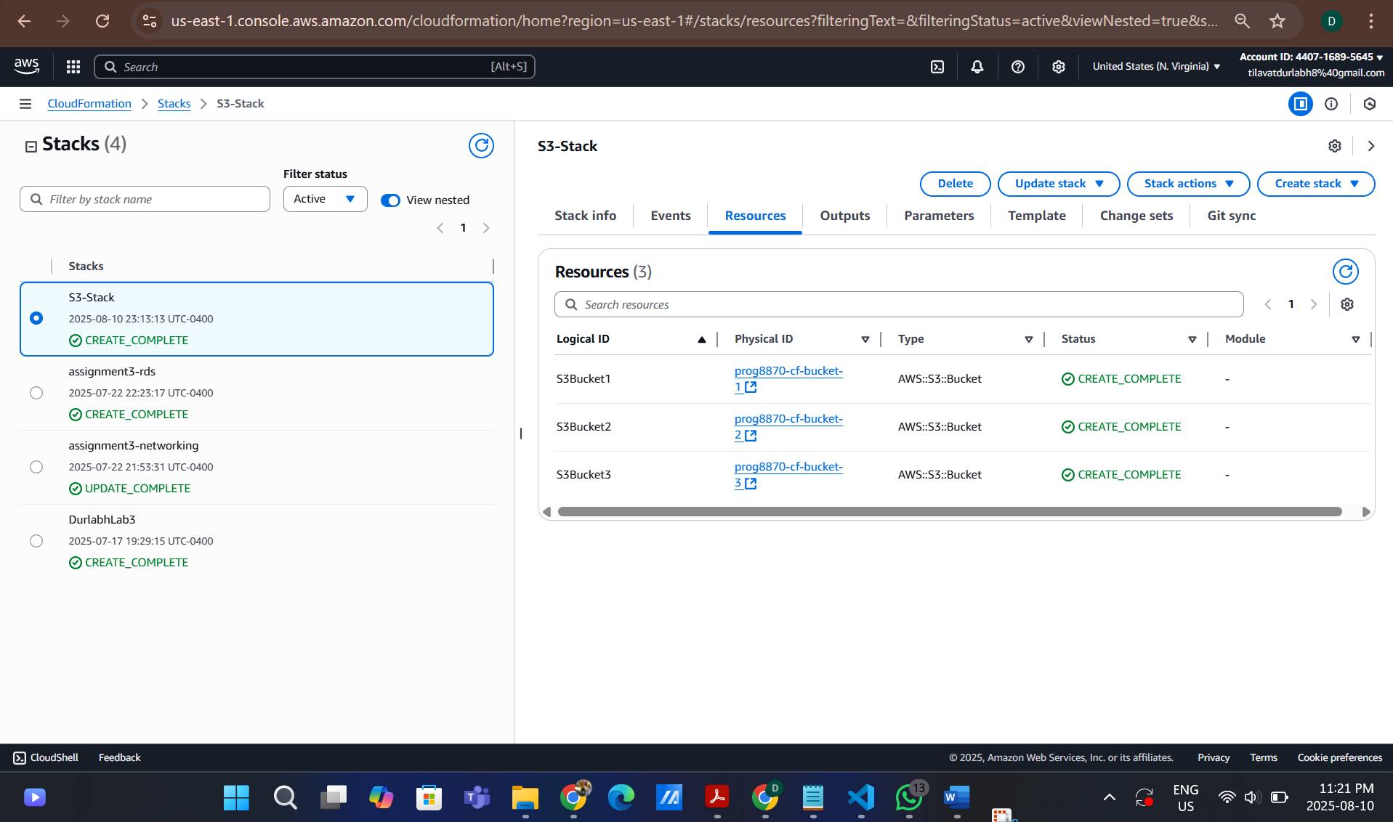

EC2 Stack:

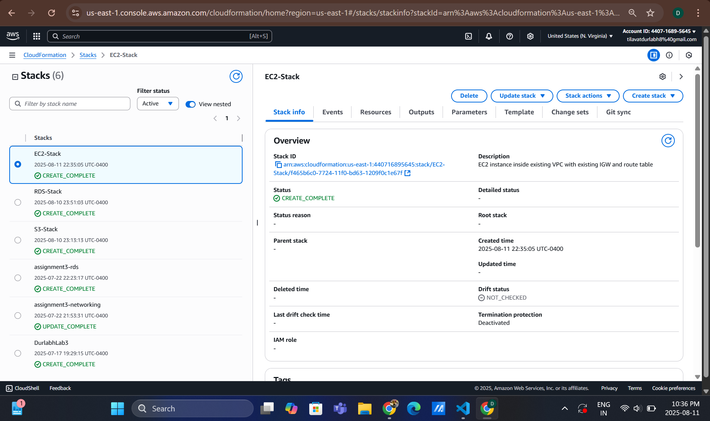

RDS Stack:

